sWEEK-1

PROGRAME-1

AIM: Download and installation of java

Step 1 : Search for java development kit in chrome to download java

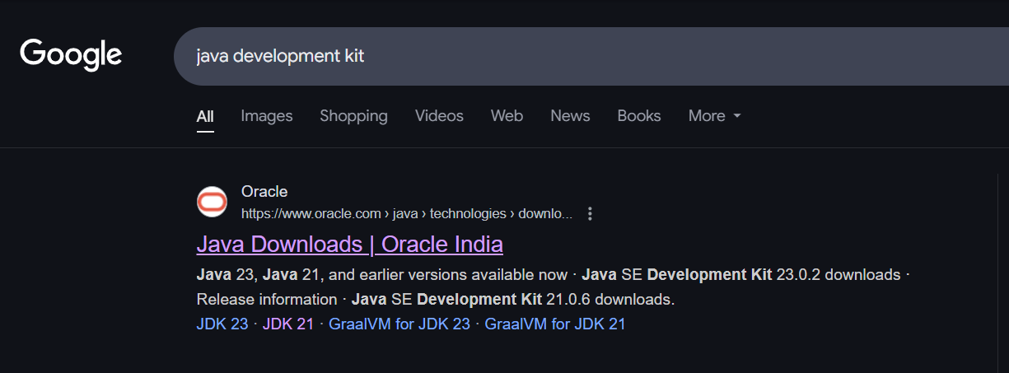

Step 2:Open oracle website. Then select JDK21 and download the type of version for your computer

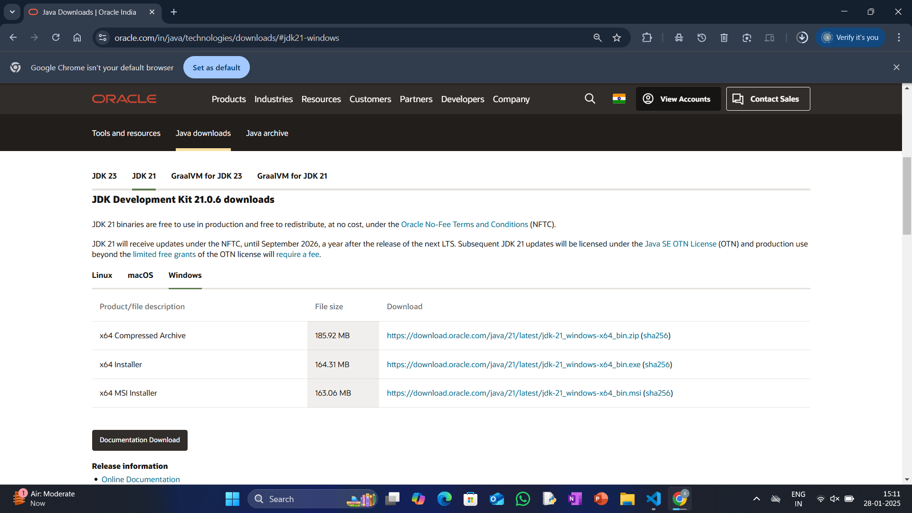

Step 3: after downloading , it will appear like the link below. Click on the link for futher installation of java software.

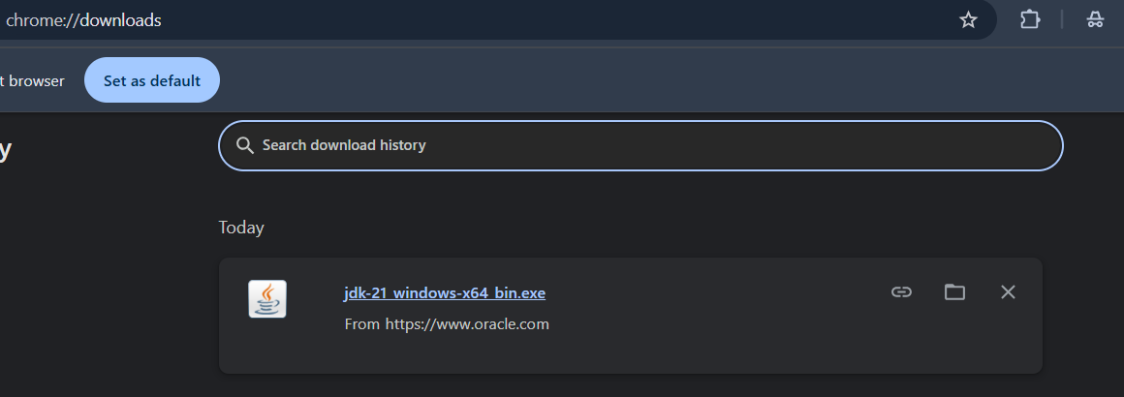

Step 4: click on the next button for futher process of installation of java in computer. At the end section click on next button for final installation.

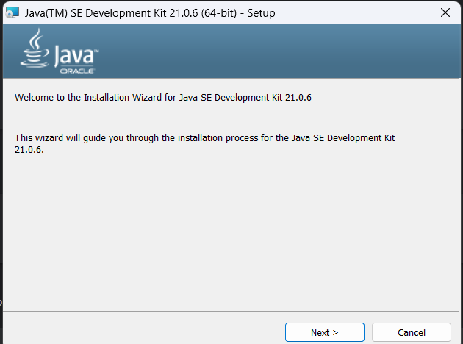

Step 5: at the end section click on the close button to end the installation.

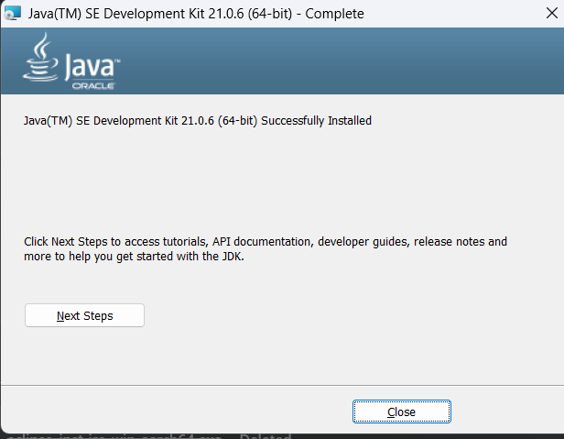

Step6 :to copy the path of the jdk kit in pc go to file manger<< local (c:) <<program files<<java<<jdk 21<<bin .

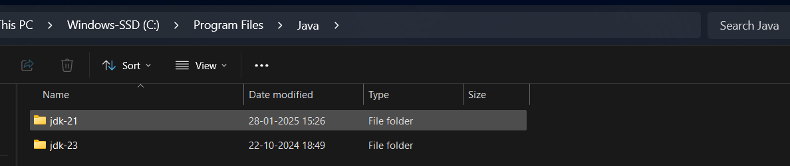

Step 7: copy path on the navigation bar .

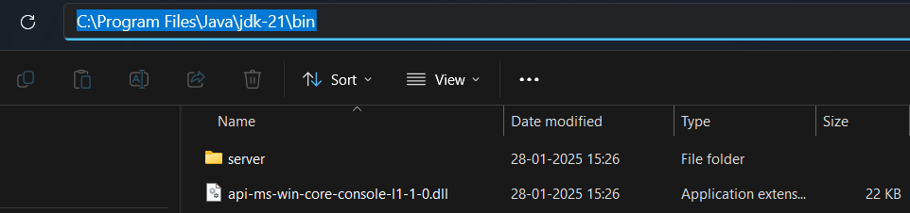

Step 8: now open environmental variables to sset the path in computer.<<click on the environmental variables.

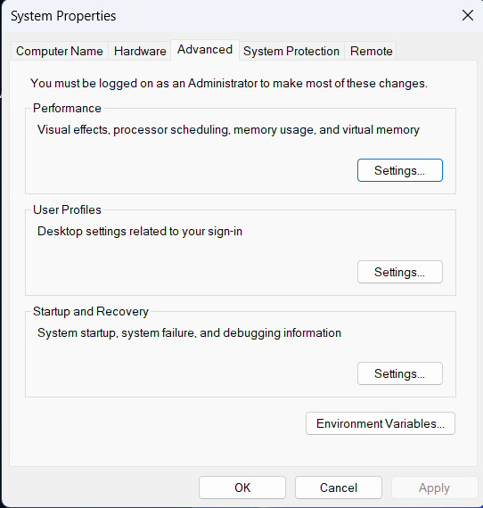

Step 9:after environmental variables another slide will appear of two sections as user variables and system variables<<click on the system variables.<<path<<click on the edit option below .

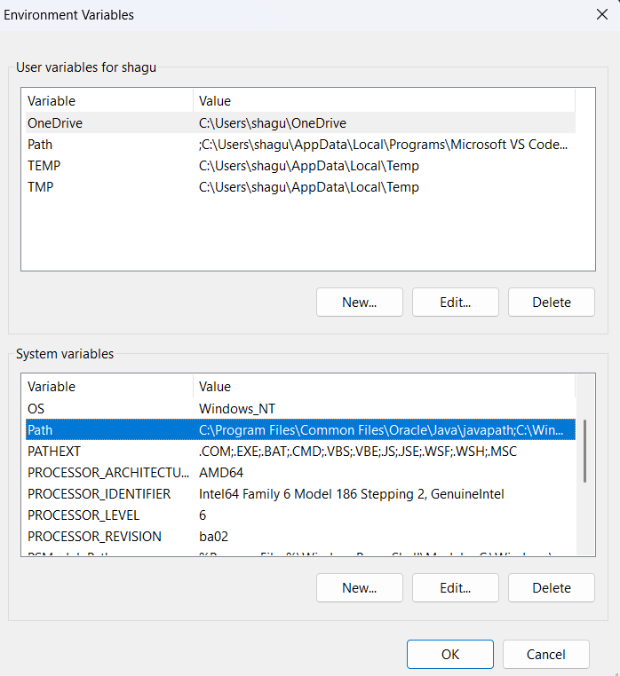

Step 10:select new << past the path with we have copied on the navigation bar .

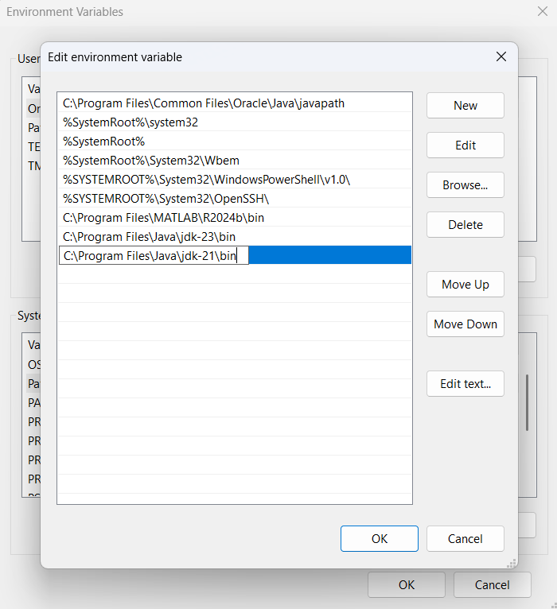

Step 11:to check the version installed <<open command prompt<<type java - - version <<enter<<downloaded version will be displayed.

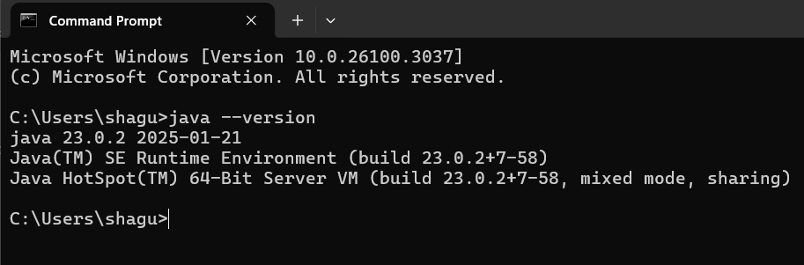

PROGRAM 2:

AIM: To write a java program to print the message

“Welcome programming printing “.

Step 1:open notepad<<save the note pad in the path[desktop<<oops<<week 1<<hello.java

CODE:

class hello{

public static void main(String [ ] args){

System.out.println(“Welcome to java programming”);

}

}

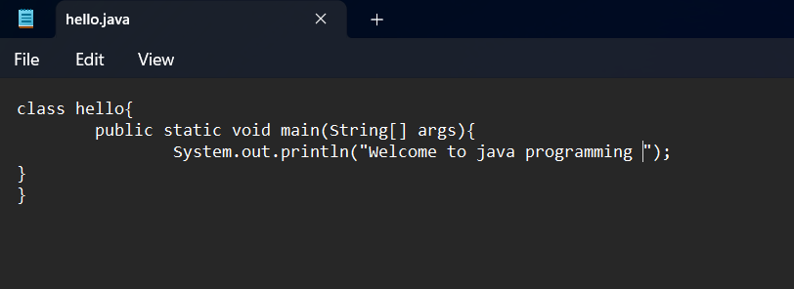

Step 2: to the path clear it and type cmd for running the program.

 

Step 3:follow commands as: javac hello.java<<enter<<jav hello

The program runs successfully.And creates a java clsss as shown below .

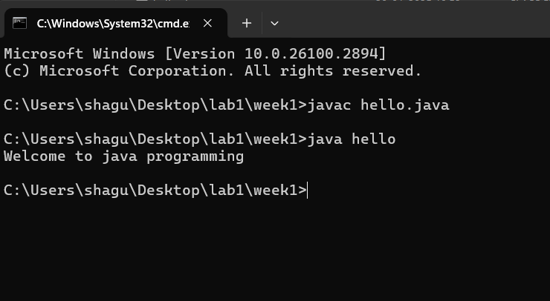

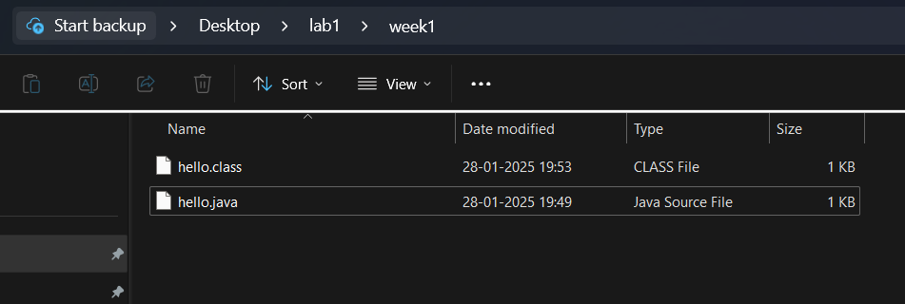

PROGRAME 3:

AIM : To write a java program to print the name,section and roll no .

Step 1:open notepad<<save the note pad in the path[desktop<<oops<<week 1<<hello.java

CODE:

class hello{

public static void main(String [ ] args){

System.out.println(“name : syed ”);

System.out.println(“roll number : AV.SC.U4CSE244444 ”);

System.out.println(“class and section: CSE -A ”);

}

}

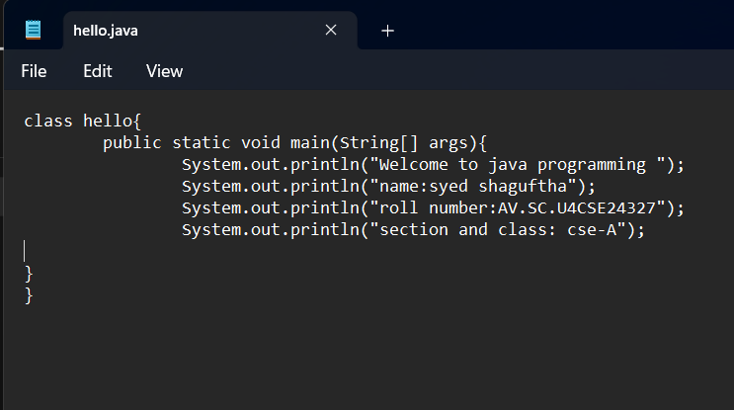

Step 2: to the path clear it and type cmd for running the program.

 

Step 3:follow commands as: javac hello.java<<enter<<jav hello

The program runs successfully.And creates a java clsss as shown below .

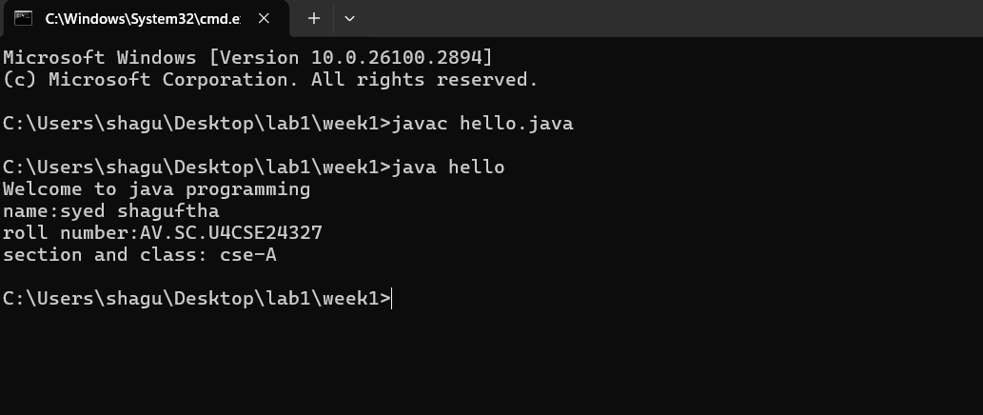



WEEK-2:

PROGRAM 1:

AIM: To write java program to calculate the area of rectangle .

Step 1:open notepad<<save the note pad in the path[desktop<<oops<<week 1<<exam.java

CODE:

import java.util.Scanner;

class exam{

public static void main(String[] args){

Scanner input= new Scannner(System.in);

System.out.print(“enter the length-l:”);

float l=input.nextFloat();

System.out.print(“enter the length-l:”);

float l=input.nextFloat();

System.out.print(“enter the breadth-b”);

float l=input.nextFloat();

float area=l*b;

System.out.print(“area is :”+area);

}

}

Step 2:open code in commond prompt and run it.

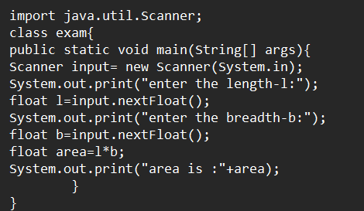

Step 3:enter the commands as javac exam.java <<java exam.the program is excuted successfully.

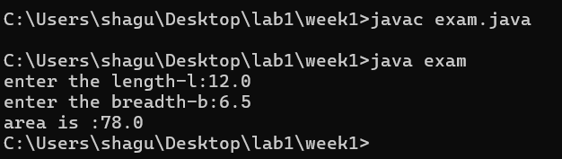

Step 4:after runner the program system automatically creates a class for it .

ERRORS:

|  |  |  |
| --- | --- | --- |
| S.NO | ERROR MEASSAGE | ERROR RECTIFICATION |
| 1. | Error:”;”expected | Inserted “;”in line7 |
| 2. | Error:”?”unkown sysmbol | Replaced”?”with “:” |

IMPORTANT POINTS:

1. used Scanner library to get input from user in run time .

2. ”import java.util.Scanner;”-step to import library.

3. “Scanner input=new Scanner(System.in);”-step to use the scanner .

**PROGRAM-2:**

1. AIM: To write java program to convert temperature from celcius to farenheit and vice via.

Step 1:open notepad<<save the note pad in the path[desktop<<oops<<week 1<<exam.java

CODE:

//code for celciius to farenheit

import java.util.Scanner;

class exam{

public static void main(String[ ] args){

Scanner input=new Scanner(System.in);

System.out.print(“Enter the celcius :”);

float c:input.nextFloat();

float f=(c*9/5)+32;

System.out.print(“Farenheit heat :”+f);

}

}

Step 2:open in commond prompt and run it.

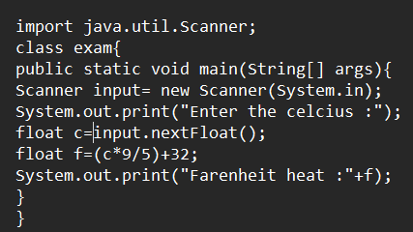

Step 3: enter the commands as javac exam <<java exam the program is excuted successfully.

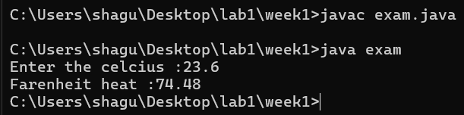

Step 4:After runner the program system automatically creates a class of it.

ERRORS:

|  |  |  |
| --- | --- | --- |
| S.NO | ERROR MESSAGE | ERROR RECTIFICATION |
| 1. | Error :”:” unknow symbol | Replace”:” with”=” |
| 2. | Error: “scanner”small letter case censitive | “Scanner” |

IMPORTANT POINTS:

1.used Scanner library to get input from user in run time.

2.”import java.util.Scanner;”-step to import library.

3.”Scanner input= new Scanner(System.in);”-step to use the scanner.

**PROGRAM**

1. AIM:To write java program to convert temperature from farenheit to celceius.

CODE:

//code for farenheit to celciius

import java.util.Scanner;

class exam{

public static void main(String[ ] args){

Scanner input=new Scanner(System.in);

System.out.print(“Enter the farenheit :”);

float f:input.nextFloat();

float c=(f-32)*5/9;

System.out.print(“celcius temparature :”+c);

}

}

Step 2:open in commond prompt and run it.

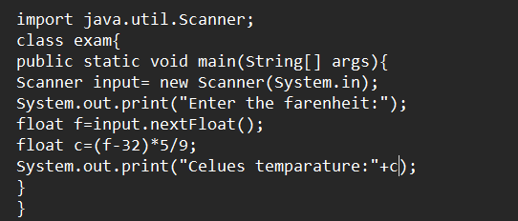

Step 3: enter the commands as javac exam <<java exam the program is excuted successfully.

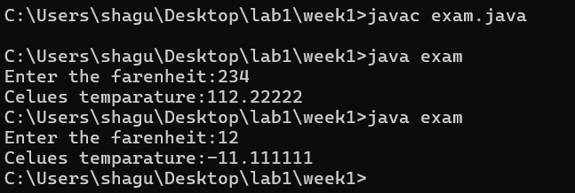

Step 4:After runner the program system automatically creates a class of it.

ERRORS:

|  |  |  |
| --- | --- | --- |
| S.NO | ERROR MESSAGE | ERROR RECTIFICATION |
| 1. | Error :”oout” unknow keywoard | Replace”oout” with”out” |
| 2. | Error: “scanner”small letter case censitive | “Scanner” |

IMPORTANT POINTS:

1.used Scanner library to get input from user in run time.

2.”import java.util.Scanner;”-step to import library.

3.”Scanner input= new Scanner(System.in);”-step to use the scanner.

**PROGRAM**

1. AIM: To write java program to calculate the simple

CODE:

Import java.util.Scanner;

class exam{

public static void main(String[ ] args){

Scanner input=new Scanner(System.in);

System.out.print(“enter the principle value(p):”);

float p=input.nextFloat();

System.out.print(“enter the rate of interest value(r):”);

float r=input.nextFloat();

System.out.print(“enter the time period value(t):”);

float t=input.nextFloat();

float si=(p*t*r)/100;

System.out.println(“simple interest is:”+si);

}

}

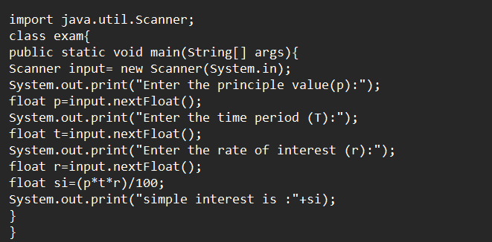

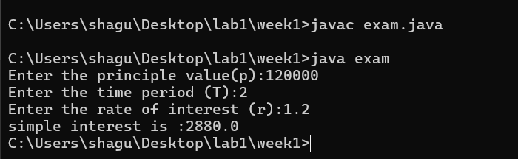

ERRORS:

|  |  |  |
| --- | --- | --- |
| S.NO | ERROR MESSAGE | ERROR RECTIFICATION |
| 1. | Error :”T” is not declred | Replace:”T” with”t” |
| 2. | Error : expected’;’ in line 8 | Insert ‘;’ in line 8 end |

IMPORTANT POINTS:

1.java is a case sensitive language so “apple” is different from “APPLE”,so clear declaration of variables is important..

1. AIM: To write a program to find the largest of three numbers using ternary operators.

Step 1:open notepad<<save the note pad in the path[desktop<<oops<<week 1<<exam.java

CODE:

import java.util.Scanner;

class exam{

public static void main(String [ ] args){

Scanner input=new Scanner(System.in);

System.out.print(“enter n1:”);

int n1=input.nextInt();

System.out.print(“enter n2:”);

int n2=input.nextInt();

System.out.print(“enter n3:”);

int n3=input.nextInt();

int largest=(n1>=n2)?((n1>=n3)?n1:n3):((n2>=n3)?n2:n3);

System.out.println(“the lsrgest number is :”+lsrgest);

}

}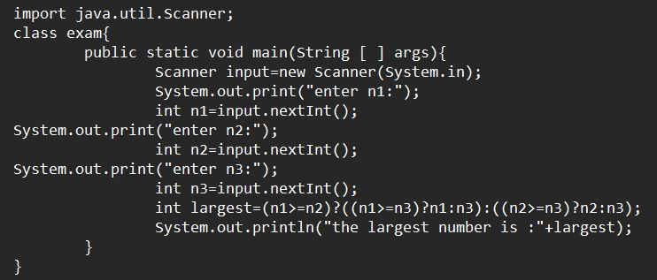

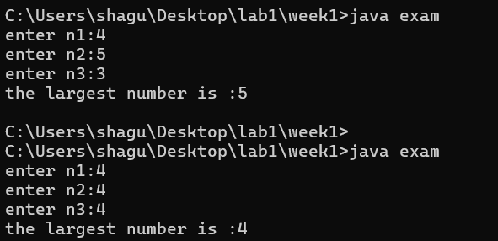

ERRORS:

|  |  |  |
| --- | --- | --- |
| S.NO | ERROR MESSAGE | ERROR RECTIFICATION |
|  | Error :”;” expected in line 6 | Insert”;” in end of line 6 |
|  | Error :”nextint();” non identified | Replace”next.Int();” |

IMPORTANT POINTS:

1. Ternary operators: a shorthand for the if-else statement, used to execute condition-based operations in a single line.
2. It evaluates a Boolean condition and returns trueValue if the condition is true, otherwise it returns falseValue.
3. AIM: To write a program for the factorial of the numbers.

Step 1:open notepad<<save the note pad in the path[desktop<<oops<<week 1<<exam.java

CODE:

import java.util.Scanner;

class exam{

public static void main(String[] args){

Scanner input=new Scanner(System.in);

System.out.println("fibinocci series");

System.out.println("enter a number:");

int n =input.nextInt();

int f1=0,f2=1;<br>

System.out.println(" "+f1);

System.out.println(" "+f2);

for ( int i=1;i<=n;i++){

int f3=f1+f2;

System.out.println(" "+f3);

f1=f2;

f2=f3;

}

}

}

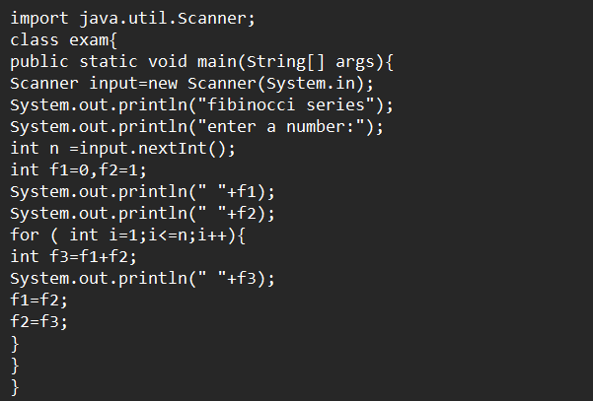

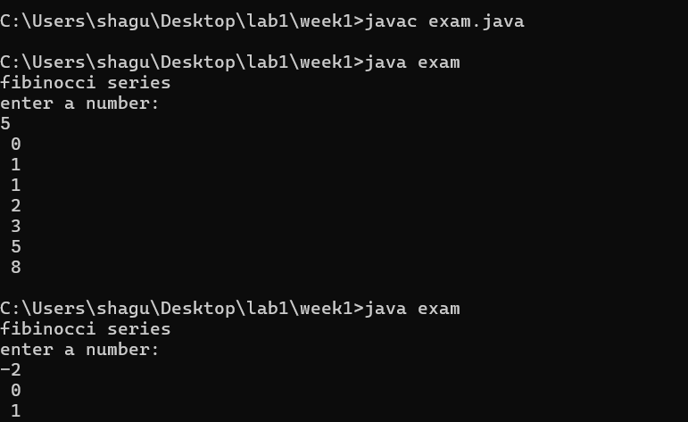

ERRORS:

|  |  |  |
| --- | --- | --- |
| S.NO | ERROR MESSAGE | ERROR RECTIFICATION |
|  | Error: line-9 illegal start of expression | Rebuilt of the line -9 |
|  | Error :iteration error | Correct iteration inserted |

IMPORTANT POINTS:

1.Java for loop is a control flow statement that allows code to be executed repeatedly based on a given condition.

2.The for loop in java provides an efficient way to iterate over a range of values ,execute code multiple times,or traverse arrays and collections.

WEEK-3

PROGRAME-1

AIM: To write a program for car color and all respective complextions using constructor and method.

Step 1:open notepad<<save the note pad in the path[desktop<<oops<<week 1<<car.java

CODE:

class car{

//creating the attributes requires for the classs

String car_name,car_color,car_brand,fule_type;

int maleage;

//constructor

car(String car_name,String car_color,String car_brand,String fule_type,int maleage){

this.car_name=car_name;

this.car_color=car_color;

this.car_brand=car_brand;

this.fule_type=fule_type;

this.maleage=maleage;

}

//creating the methods forte class

public void start(){

System.out.println("this is start statement: "+car_name+" "+car_color);

}

public void stop(){

System.out.println("this is start statement: "+car_brand+" "+fule_type);

}

public void services(){

System.out.println("this is start statement: "+maleage);

}

public static void main(String[] args){

//creating the object for the class

car car1=new car("maruthi","navy blue","KIA","petrol", 1234);

car1.start();

car car2=new car("maruthi","navy blue","KIA","petrol", 1234);

car2.stop();

car car3=new car("maruthi","navy blue","KIA","petrol", 1234);

car3.services();

System.out.println("\n THANK YOU FOR APPLYING THIS");

}

}

CLASS DIAGRAM:

|  |
| --- |
| Car() |
| +car_name:string  +car_color:string  +car_brand:string  +fule_type: int  +maleage:int |
| +start:void()  +stop:void()  +static:void() |

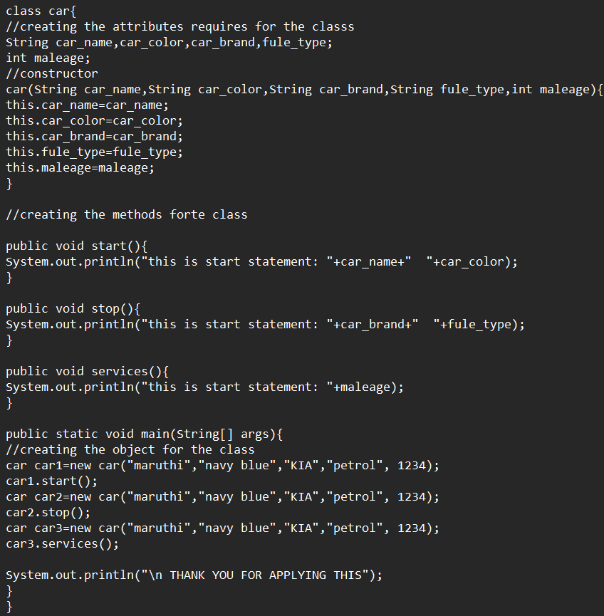

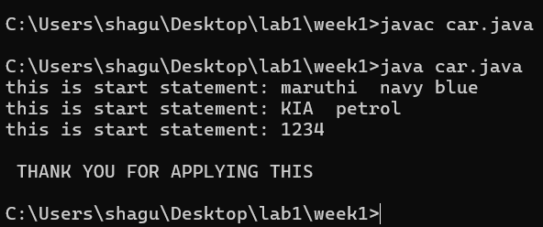

ERRORS:

|  |  |  |
| --- | --- | --- |
| S.NO | ERROR MESSAGE | ERROR RECTIFICATION |
|  | Error: line7 expected ‘; | Inserted ‘;’ |
|  | Error :line 7 unknow’__’ | Removed ‘_’ |
|  | Error : correct data type declararion in constructor | Rectified by declaring the data type as String and int. |

IMPORTANT POINTS:

1. Java constructor is used to save the variables present in different or same class or methods.

2. In Java, the this keyword refers to the current instance of a class. It is commonly used to distinguish between instance variables and parameters with the same name, or to refer to the current object from within a method or constructor.

3. In Java, a method is a block of code that performs a specific task and can be invoked to execute that task. It typically consists of a method signature (name, return type, and parameters) and the body of the method, which contains the logic.

**PROGRAM**

AIM: To write a program for car color and all respective complextions using constructor and method.

Step 1:open notepad<<save the note pad in the path[desktop<<oops<<week 1<<BANK.java

CODE:

import java.util.Scanner;

class BankAccount {

 // Class-level variable to store balance

    private float existing;

    private Scanner input; // Single Scanner instance for input

    public  String name;

    // Constructor

    public BankAccount() {

        input = new Scanner(System.in);

        System.out.println("Enter the account holder name :");

        this.name=input.next();

        System.out.print("Enter existing amount in bank account: ");

        this.existing = input.nextFloat();

    }

    // Deposit method

    public void deposit() {

        System.out.print("Enter amount to be deposited: ");

        float deposit = input.nextFloat();

        existing += deposit;

        System.out.println("Existing amount now is: " + existing);

    }

    // Withdrawal method

    public void withdrawal() {

        System.out.print("Enter amount to be withdrawn: ");

        float withdrawal = input.nextFloat();

        if (existing < withdrawal) {

            System.out.println("Not sufficient balance.");

        } else {

            existing -= withdrawal;

            System.out.println("Remaining balance: " + existing);

        }

    }

    // Main method

    public static void main(String[] args) {

        BankAccount customer1 = new BankAccount();

        customer1.deposit();

        customer1.withdrawal();

        System.out.println("thank you " + customer1.name + " for using our bank");

}

}

CLASS DIAGRAM:

|  |
| --- |
| BankAccount |
| -existing:float  +name:String |
| +BankAccount()  +deposit:void()  +withdraw:void() |

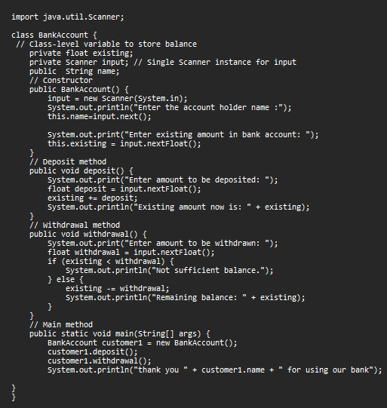

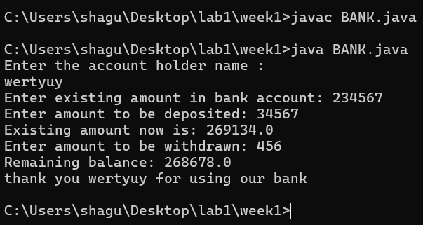

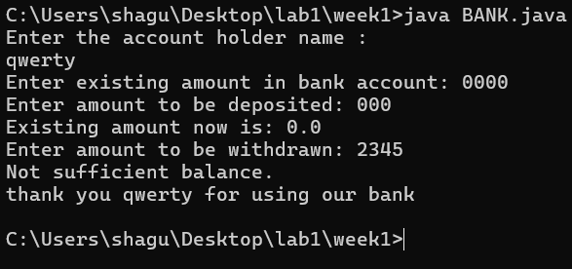

ERRORS:

|  |  |  |
| --- | --- | --- |
| S.NO | ERROR MESSAGE | ERROR RECTIFICATION |
|  | Error: nextString(); wrong identifier | Rectification: next(); |
|  | Error :line 7 unknow’__’ | Removed ‘_’ |
|  | Error : if statement ‘{}’ expected | Inserted ‘{}’ |

IMPORTANT POINTS:

1. Java constructor is used to save the variables present in different or same class or methods.

2. In Java, the this keyword refers to the current instance of a class. It is commonly used to distinguish between instance variables and parameters with the same name, or to refer to the current object from within a method or constructor.

3. In Java, a method is a block of code that performs a specific task and can be invoked to execute that task. It typically consists of a method signature (name, return type, and parameters) and the body of the method, which contains the logic.

WEEK-4

PROGRAME-1

AIM: To write a program for printing the title of the book and the author and year of publication using the constructors

Step 1:open notepad<<save the note pad in the path[desktop<<oops<<week 1<<person.java

CODE:

class book{

//creating the variable

public String title_of_book;

public String author;

public int year_publication;

//creating a constructor

book(String title_of_book,String author,int year_publication){

this.title_of_book=title_of_book;

this.author=author;

this.year_publication=year_publication;

}

//creating the method to print DETAILS

public void details(){

System.out.println("the title of the book is: "+title_of_book+"\nThe author of te book is: "+author+"\nthe year of publication is:"+year_publication+"\n");

}

//creating the main class and objects for the method

public static void main(String[] args){

book one=new book("THE GREAT INDIAN RIVERS","DR.SHIVARAM",1989);

one.details();

book two=new book("ANGLES IN TIBET","S.SLUMP",2001);

two.details();

System.out.println("\nThese are the details of the two books which are famously treading nowadays\n THANK YOU ");

}

}

CLASS DIAGRAM:

|  |
| --- |
| Book |
| +title_of_book:string  +author:string  +year_publication:int |
| +book()  +detailes:void() |

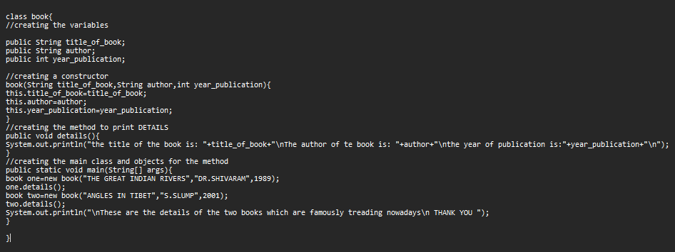

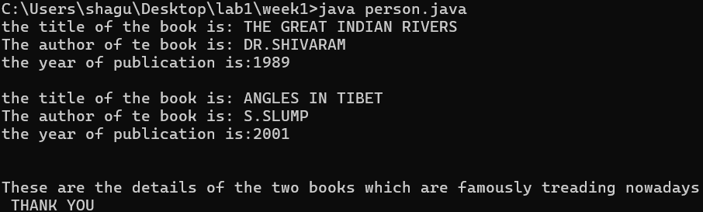

ERRORS:

|  |  |  |
| --- | --- | --- |
| S.NO | ERROR MESSAGE | ERROR RECTIFICATION |
| 1. | Error: “ this.year_public;=year_public;” | Rectification: removed the ‘;’ |
| 2. | Error :”missing ‘;’-“System.out.println(“..”); | Inserted the ‘;’ in the line. |

IMPORTANT POINTS:

1. Java constructor is used to save the variables present in different or same class or methods.
2. In Java, the this keyword refers to the current instance of a class. It is commonly used to distinguish between instance variables and parameters with the same name, or to refer to the current object from within a method or constructor.

PROGRAME-2s

AIM: To write a program for printing the title of the book and the author and year of publication using the constructors

Step 1:open notepad<<save the note pad in the path[desktop<<oops<<week 1<<exam.java

CODE:

class myclass{

//creating the variables

static int count=0;

final double pi=3.1415;

//creating a constructor

myclass(){

count++;// creatinfg the condition for the increment of the static count variable

}

//method to print the values

public void values(){

System.out.println(+count);

System.out.println(+pi);

}

//object and the main function

public static void main(String[] args){

//creating the four objects to check the code for the condition of constructor

myclass one=new myclass();

one.values();

myclass two=new myclass();

two.values();

myclass three=new myclass();

three.values();

myclass four=new myclass();

four.values();

}

} CLASS DUAGRAM:

|  |
| --- |
| Myclass |
| -count:0  -pi:3.1415 |
| +myclass()  +values:void() |

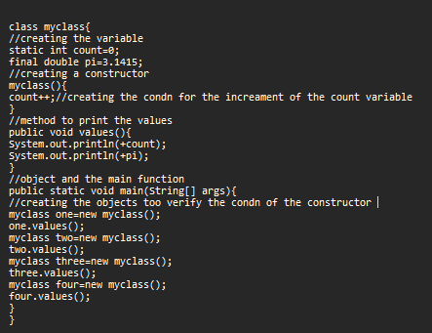

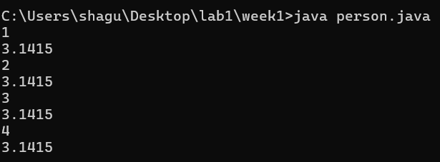

ERRORS:

|  |  |  |
| --- | --- | --- |
| S.NO | ERROR MESSAGE | ERROR RECTIFICATION |
|  | Error: argument required of type int | Rectification: rectified the argument issue. |
|  | Error :line 7 unknow’__’ | Removed ‘_’ |
|  | Error : if statement ‘;’ expected | Inserted:count++; |

IMPORTANT POINTS:

1. Java constructor is used to save the variables present in different or same class or methods.
2. In Java, the ++ operator increments a variable by 1, either as **pre-increment** (++x) or **post-increment** (x++).
3. In Java:
4. **static**: A static variable belongs to the class, not instances, meaning all objects share the same value.
5. **final**: A final variable cannot be modified once assigned, making it constant.

WEEK-5

PROGRAME-1

AIM: create a calculator using the operations including add,sub,multi and div using multilevel inheritanceand display the desipred output

Step 1:open notepad<<save the note pad in the path[desktop<<oops<<week 1<<inheritance.java

CODE:

import java.util.Scanner;

class Calculator {

// Base class for the calculator

Calculator(){

System.out.println("\nthis is the calculator program\n");

System.out.println("------------------------------------");

} }

class Simple extends Calculator {

public int add(int a, int b) {

return a + b;

}

public int subtract(int a, int b) {

return a - b;

}

public int multiply(int a, int b) {

return a * b;

} }

class Super extends Simple {

public int square(int a) {

return a * a;

}

public int cube(int a) {

return a * a * a;

}

public double squareRoot(int a) {

return Math.sqrt(a);

}

}

class Advanced extends Super {

public double divide(int a, int b) {

if (b != 0) {

return (double) a / b;

} else {

return 0; // Division by zero is not allowed.

}

}

public int modulus(int a, int b) {

return a % b;

}

}

public class inherit {

public static void main(String[] args) {

Scanner input=new Scanner(System.in);

System.out.println("enter a value:");

int a=input.nextInt();

System.out.println("enter b value: ");

int b=input.nextInt();

Simple simpleCalc = new Simple();

System.out.println("Addition: " + simpleCalc.add(a, b));

System.out.println("Subtraction: " + simpleCalc.subtract(a, b));

System.out.println("Multiplication: " + simpleCalc.multiply(a, b));

Advanced advancedCalc = new Advanced();

System.out.println("Division: " + advancedCalc.divide(a, b));

System.out.println("Modulus: " + advancedCalc.modulus(a, b));

Super superCalc = new Super();

System.out.println("Square: " + superCalc.square(a));

System.out.println("Cube: " + superCalc.cube(b))

System.out.println("Square Root: " + superCalc.squareRoot(b));

} }

|  |
| --- |
| Calculator |
| +Calculator() |

|  |
| --- |
| Siimple |
| +add(int):return int  +substract(int):return int  +multiply(int):return int |

|  |
| --- |
| Super |
| +square(double):return double  +cube(int):return int  +squareRoot(double):double |

|  |
| --- |
| Advanced |
| +divide(double):return double  +module(int):return int |

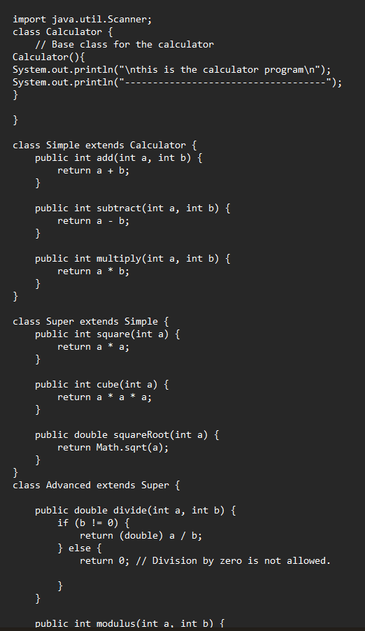

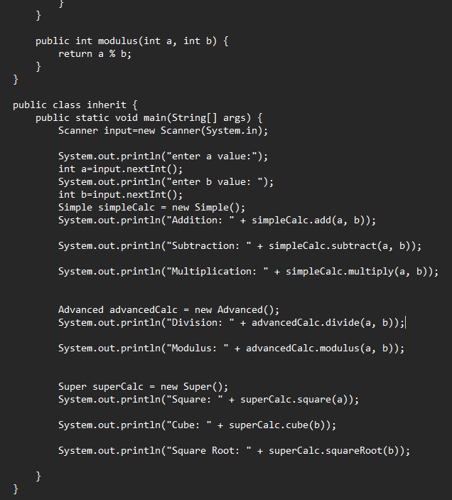

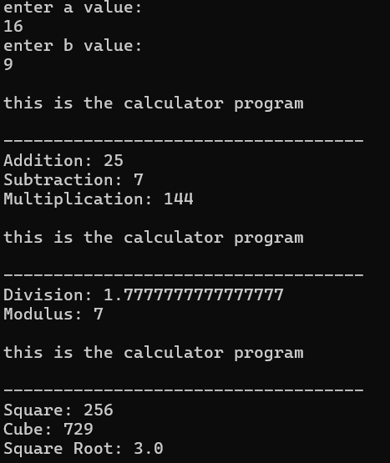

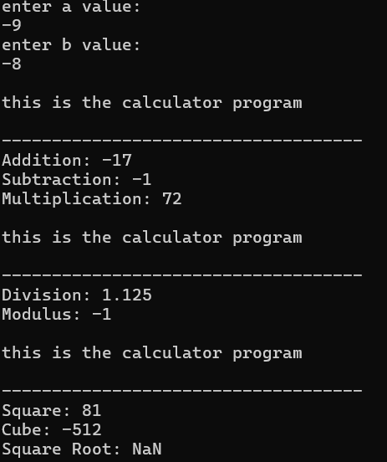

ERRORS:

|  |  |  |
| --- | --- | --- |
| S.NO | ERROR MESSAGE | ERROR RECTIFICATION |
|  | Error: mutipile inheritance in the Advanved class | Implemented Advanced class from Super class. |
|  | Error : Scanner; | Scanner(System.in); |

IMPORTANT POINTS:

1. Multiple inheritance lets a class inherit from multiple parents, combining their features, but can cause issues like the diamond problem, resolved by MRO.
2. Math.sqrt() in Java calculates the square root of a non-negative double value and returns a double result, or NaN if the input is negative.
3. The import java.util.Scanner; statement in Java allows you to use the Scanner class from the java.util package, which is commonly used to read user input from the console.

PROGRAME-2

AIM: create a java program of a vehicle entry company hireachical wants to develop his system that maintains information about different types of cars and bikes and they need a program to store details about each vehicle auch as brand and speed

Step 1:open notepad<<save the note pad in the path[desktop<<oops<<week 1<<inheritance.java

CODE:

class Vehicle{

String brand;

int speed;

Vehicle(String brand,int speed){

this.brand=brand;

this.speed=speed;

}

void Details(){

System.out.println("Brand:"+brand);

System.out.println("\nSpeed:"+speed);

System.out.println("------------------------------");

}

}//End of super class

class CARS extends Vehicle{

int doors;

int capacity;

public CARS(String brand,int speed,int doors,int capacity){

super(brand, speed);

this.doors=doors;

this.capacity=capacity;

}

void cardetails(){

System.out.println("\nNumber of doors:"+doors);

System.out.println("\nCapacity:"+capacity);

System.out.println("----------------");

}

}//End of car sub-class

class Bikes extends Vehicle{

Boolean gears;

Bikes(String brand,int speed,Boolean gears){

super(brand, speed);

this.gears=gears;

}

void bikedetails(){

if (gears==true) {

System.out.println("This bike has gears.");

}

else{

System.out.println("This bike does not have gear system.");

}

}

}//End of bike sub-class

class Trucks extends Vehicle{

int tons;

Trucks(String brand,int speed,int tons){

super(brand, speed);

this.tons=tons;

}

void truckdetails(){

System.out.println("The capacity of truck is: "+tons);

}

}//End of truck sub-class

class inherit{

public static void main(String[] args){

CARS c=new CARS("Tayota",120,5,2);

c.cardetails();

c.Details();

Bikes b=new Bikes("KTM",80,true);

b.bikedetails();

b.Details();

Trucks t=new Trucks("TATA",150,1);

t.truckdetails();

t.Details();

System.out.println("THANK YOU FOR COMING TO OUR COMPANY :) ~ ^ !");

}

}

CLASS DIAGRAMS :

|  |
| --- |
| Vehicle |
| +brand:String  +speed:int |
| +Vehicle();  +Details():void |

|  |
| --- |
| CARS |
| +doors:int  +capacity:int |
| +CARS()  +cardetails():void |

|  |
| --- |
| Bikes |
| +gears:Boolean |
| +Bikes()  +bikedetails():void |

|  |
| --- |
| Trucks |
| +tons:int |
| +Trucks()  +truckdetails():void |

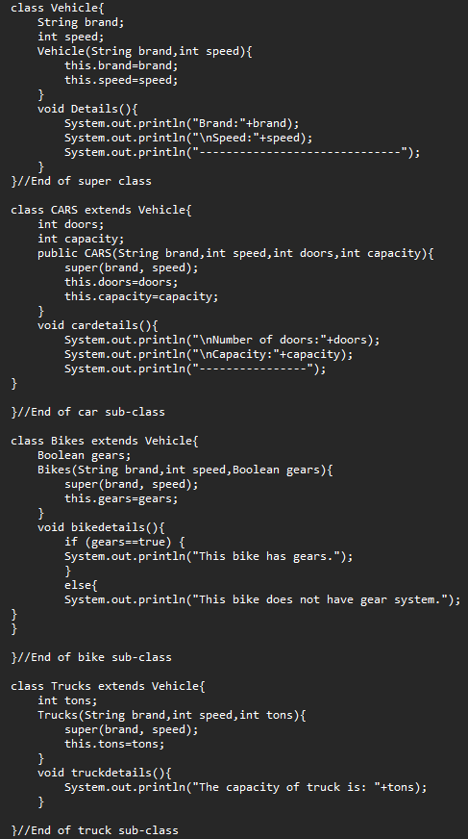

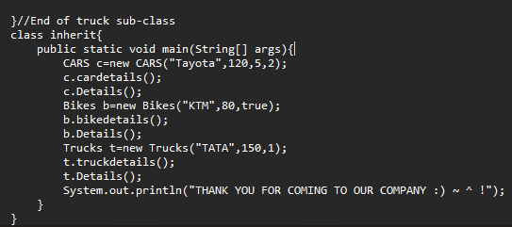

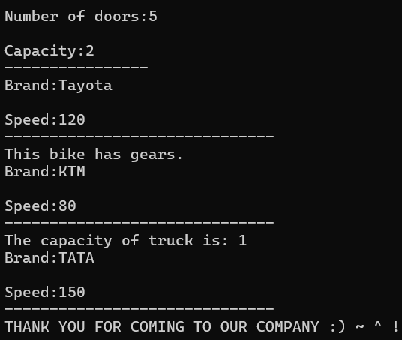

ERRORS:

|  |  |  |
| --- | --- | --- |
| S.NO | ERROR MESSAGE | ERROR RECTIFICATION |
| 1. | Error: Incorrect Constructor Arguments. | the arguments passed when creating an object match the constructor's parameter list in both **number** and **type**. |
| 2. | Error : Scanner; | Scanner(System.in); |

IMPORTANT POINTS:

1. Hierarchical inheritance is a type of inheritance where multiple subclasses inherit from a single parent class, allowing code reuse and reducing redundancy.
2. A **constructor** is a special method in a class used to initialize new objects with default or provided values. It is automatically called when an object is created and sets up the object's initial state.

WEEK-6

PROGRAME-1

AIM: To write a program for creating a shape with method calculatearea, that is overloaded for different shapes ,create a subclass circle that over riding the calculatearea method for a circle.

Step 1:open notepad<<save the note pad in the path[desktop<<oops<<week 1<<week.java

CODE:

import java.util.Scanner;

class Shape{

    float s=3;

    int l=5,b=6;

    double r=2.3;

    public void calculatarea(float s){

        System.out.print("area of a square is:");

        double area=s*s;

        System.out.println(area);

    }

    public void calculatarea(int l,int b){

        System.out.print("area of a rectangle is:");

        double area=l*b;

        System.out.println(area);

    }

    public void calculatarea(double r){

        System.out.println("over riding method");

        System.out.println("radius is:"+r);

}

}

class Circle extends Shape{

    public void calculatarea(double r){

        System.out.println("----------------------------------------");

        System.out.print("area of a circle is:");

        double area=3.14*r*r;

        System.out.println(area);

}

}

class week{

    public static void main(String[] args) {

        Shape s1=new Shape();

        s1.calculatarea(3);

        s1.calculatarea(5,6);

        s1.calculatarea(2.3);

        Circle c1=new Circle();

        c1.calculatarea(3.4);

    }

}

**CLASS DIAGRAMS :**

|  |
| --- |
| **Shape** |
| **+a:float;**  **+l,b:int;**  **+r:double;** |
| **+calculatearea(float s);**  **+calculatearea(int l, int b);**  **+calculatearea(double r);** |

|  |
| --- |
| **Circle** |
| **+calculatearea(double r);** |

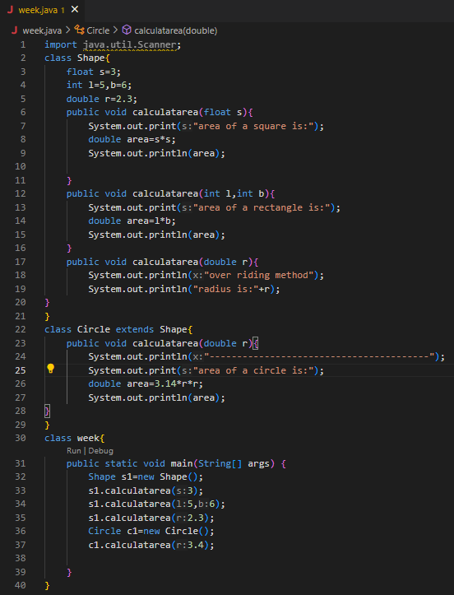

**OUTPUT:**

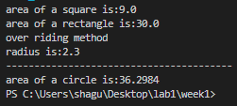

**ERROR:**

|  |  |  |
| --- | --- | --- |
| S.NO | ERROR | RECTIFICATION |
| 1. | Error:’;’ is missing in print statemnt | Rectification:inserted the’;’ in print statement |

IMPORTANT POINTS:

• Method overriding allows a subclass to provide a new version of a method already defined in its parent class.

• The method name, parameters, and return type must be the same.

• It is used to change or extend the behavior of inherited methods.

• Overriding supports runtime polymorphism (decides which method to run at runtime).

• It helps in writing flexible, reusable, and organized code

PROGRAME-2

AIM: To create calculator with over load method to perform overload i)add two integers ii)add two double iii)add three int

Step 1:open notepad<<save the note pad in the path[desktop<<oops<<week 1<<week.java

CODE:

class Calculator {

// Method 1: Add two integers

int add(int a, int b) {

return a + b;

}

// Method 2: Add two doubles

double add(double a, double b) {

return a + b;

}

// Method 3: Add three integers

int add(int a, int b, int c) {

return a + b + c;

}

}

public class q3 {

public static void main(String[] args) {

Calculator calc = new Calculator();

// Test the overloaded methods

int sum1 = calc.add(10, 20);

double sum2 = calc.add(5.5, 6.7);

int sum3 = calc.add(1, 2, 3);

// Display results

System.out.println("Sum of two integers: " + sum1);

System.out.println("Sum of two doubles: " + sum2);

System.out.println("Sum of three integers: " + sum3);

}

}

CLASS DIAGRAMS:

|  |
| --- |
| Calculator |
|  |
| + add(a: int, b: int): int  + add(a: double, b: double): double  + add(a: int, b: int, c: int): int |

|  |
| --- |
| Inherit |
|  |
| +main:void |

OUTPUT:;

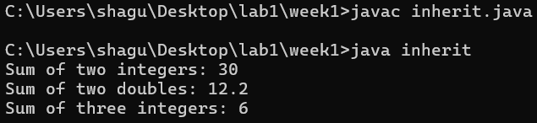

ERROR:

|  |  |  |
| --- | --- | --- |
| S.NO | ERROR | RECTIFICATION |
| 1. | Initially file name stored in another name | Rectified by changing name to the stored one. |

IMPOERTANT POINTS:

1. Method overloading means defining **multiple methods with the same name** but **different parameters**.
2. It happens **within the same class**.
3. The methods must differ in **number or type of parameters**.
4. It increases **code readability** and **flexibility**.
5. Overloading is decided at **compile-time** (compile-time polymorphism).

PROGRAME-3

AIM: To create a collage program for developing automated admission that verifies students eligibility for UG,PG programs.each program has different eligibility criteria based on the students percentage[%] in their perious qualification.

Step 1:open notepad<<save the note pad in the path[desktop<<oops<<week 1<<week.java

CODE: class AdmissionSystem {

void checkEligibility(String name, double percentage, String programType) {

if (programType.equals("UG")) {

if (percentage >= 60) {

System.out.println(name + " is eligible for Undergraduate program.");

} else {

System.out.println(name + " is NOT eligible for Undergraduate program.");

}

} else if (programType.equals("PG")) {

if (percentage >= 70) {

System.out.println(name + " is eligible for Postgraduate program.");

} else {

System.out.println(name + " is NOT eligible for Postgraduate program.");

}

} else {

System.out.println("Invalid program type: " + programType);

}

}

}

public class inherit {

public static void main(String[] args) {

AdmissionSystem admission = new AdmissionSystem();

// Test cases with hardcoded values

admission.checkEligibility("Ram", 68.5, "UG");

admission.checkEligibility("raj", 68.5, "PG");

System.out.println("thank you for coming to our collage");

}

}

CLASS DIAGRAMS :

|  |
| --- |
| AdmisssionSystem |
|  |
| + checkEligibility(name: String,  percentage: double,  programType: String): void |

|  |
| --- |
| Inherit |
|  |
| +main:void |

OUTPUT:

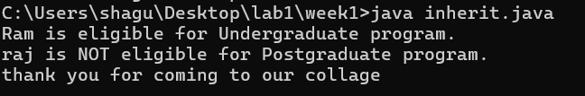

ERROR:

|  |  |  |
| --- | --- | --- |
| S.NO | ERROR | RECTIFICATION |
| 1. | Error in constructor declaration | Rectified by giving correct data type name for the taken variables |

IMPORTANT POINTS:

1. **if statement** is used to check a condition. If it's true, the code inside runs.
2. **else if** checks another condition if the first if is false.
3. You can have **multiple else if** blocks to check different conditions.
4. **else** runs when **none** of the above conditions are true.
5. Used to perform **different actions** based on **different conditions**.

PROGRAME-4

AIM: To write a program for creating vehicle class with amethod displayInfo().Overide this method in the car subclass to provide specific information about cars[car company,car model, car prize,seating capacity, petrol or not{Boolean}]

Step 1:open notepad<<save the note pad in the path[desktop<<oops<<week 1<<week.java

CODE:

class Vehicle {

String car_company;

String car_model;

long car_prize;

int seating_capacity;

boolean petrol;

Vehicle(String car_company, String car_model, long car_prize, int seating_capacity, boolean petrol) {

this.car_company = car_company;

this.car_model = car_model;

this.car_prize = car_prize;

this.seating_capacity = seating_capacity;

this.petrol = petrol;

}

void displayInfo() {

System.out.println("Car company is: " + car_company);

System.out.println("Model of the car is: " + car_model);

System.out.println("Prize of the car is: " + car_prize);

System.out.println("Seating capacity of the car: " + seating_capacity);

System.out.println("Fuel type (petrol?): " + petrol);

}

}

class Car extends Vehicle {

Car(String car_company, String car_model, long car_prize, int seating_capacity, boolean petrol) {

super(car_company, car_model, car_prize, seating_capacity, petrol);

}

@Override

void displayInfo() {

System.out.println("----- Car Details (Overridden Method) -----");

System.out.println("Car company is: " + car_company);

System.out.println("Model of the car is: " + car_model);

System.out.println("Prize of the car is: " + car_prize);

System.out.println("Seating capacity of the car: " + seating_capacity);

System.out.println("Fuel type (petrol?): " + petrol);

System.out.println("-------------------------------------------");

}

}

public class inherit {

public static void main(String[] args) {

Car car1 = new Car("Ford", "X-Series", 2000000, 4, true);

car1.displayInfo();

Car car2=new Car("mersidies","BMW",23009900,6,true);

car2.displayInfo();

}

}

CLASS DIAGRAMS :

|  |
| --- |
| Vehicle |
| +car_company:String  +car_model:String  +car_prize:long  +seating_capacity:int  +petrol: Boolean |
| +Vehicle(String,String,long,int,boolean)  +displayInfo():void |

|  |
| --- |
| Car |
| (inherit all from Vehicle) |
| +car(String,String,long,int,boolean)  +displayInfo():void() @Overiden |

OUTPUT:

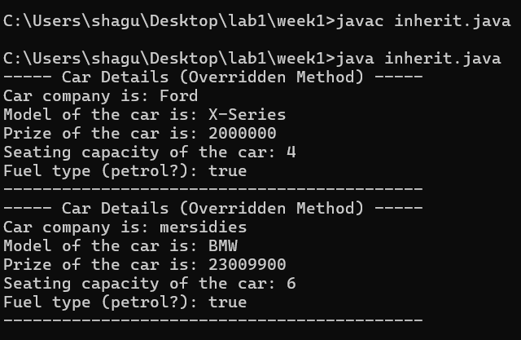

ERROR:

|  |  |  |
| --- | --- | --- |
| S.NO | ERROR | RECTIFICATION |
| 1. | Error :’;’ missing in printing statement | Rectified by inserting the ‘;’ in the printing statement. |

IMPORTANT POINTS:

1. **Method overriding** allows a subclass to provide a new version of a method already defined in its parent class.
2. It enables **runtime polymorphism**, where the method call is decided at **runtime** based on the object type.
3. Methods are defined **inside a class** to perform specific tasks or actions.
4. They usually have a **name**, **return type**, and **optional parameters**, and can be called using an object of the class